In Class Assignment

**Problem 1**

For this problem, you will directly write to the HTML page (via document.write calls).

You will call the following JSON web service:

http://www.geoplugin.net/json.gp?ip=64.17.241.5

You are to return the request, city, latitude, and longitude.

This can all be done on the form’s startup.

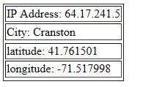

**Problem 2**

For this problem, you will find out about the carbon output for a particular state. For this exercise, you will create an HTML page and have the webservice call fill in the HTML elements. In addition, you will need a text box on the page where the user can enter the state name (put the full name, not an abbreviation) and a button that will be used to call the webservice (i.e., this webservice will not load on startup).

The webservice is:

http://carma.org/api/1.1/searchLocations?name=Rhode Island

The form should look something like this:

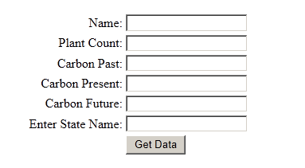

And after entering the data:

